**Project Design Phase-I**

**Solution Architecture**

|  |  |
| --- | --- |
| Date | 08 OCT 2022 |
| Team ID | PNT2022TMID20139 |
| Project Name | Project – SMART SOLUTION FOR RAILWAYS |
| Maximum Marks | 4 Marks |

Solution architecture is a complex process – with many sub-processes – that bridges the gap between business problems and technology solutions. Its goals are to:

● Find the best tech solution to solve existing business problems.

● Describe the structure, characteristics, behaviour, and other aspects of the software to project stakeholders.

● Define features, development phases, and solution requirements.

● Provide specifications according to which the solution is defined, managed, and delivered.

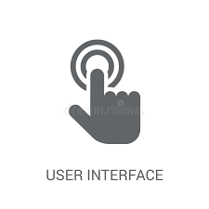

PASSENGER

****TICKET EXAMINAR

WEB USER INTERFACE

WEB DEVELOPER

4.VERIFY

QR

CODE

4.LOCATION UPDATES AND OTHER ADDED FACIITIES

UWUUWFACILITES

2.BOOK TICKET

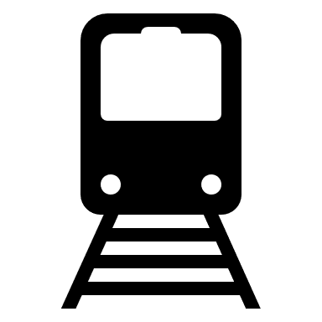****

1.DEPLOY WEB APPLICATION

3.QR GENERATOR

IOT DEVICE



PYTHON CODE

**CLOUD SERVICE**

GPS MODULE

CLOUDANT DB

IBM WATSON IOT PLATFORM